P004 - Service Delivery

Version | Approved: | Comments | Next review date
2.0  2.1 | 01/05/2019  25/06/2020 | Review – new standards  Dignity of risk | 01/09/2020  25/06/2021

Applies to:
All staff

Contents
PURPOSE 1
POLICY: Service Delivery 1
PROCEDURE: Service Delivery 5
POLICY: Nursing Notes 6
PROCEDURE: Nursing Notes 6
POLICY: Service Record 7
PROCEDURE: Service Record 7
DOCUMENTS 7

PURPOSE
Requests from clients, carers, families and other service providers are encouraged.
Referrals are made in accordance with client needs, values, beliefs and preferences.

POLICY: Service Delivery
First Call is committed to delivering services that respond to the needs and strengths of our clients, their families and their communities.
We want those who use our service to be confident that their needs have been understood, that there is a clear path for the services they will receive from First Call, and that there is assistance available to build relationships with other agencies as appropriate.
In delivering service to clients, First Call always respects the human and legal rights of the client; each client’s legal and human rights are understood and incorporated into everyday practice. FCN upholds client’s rights as outlined in the Aged Care Act 1997 Schedule 2, Carer Recognition Act 2010, User Rights Principles 2014. A list of these rights can be found at this link or in D002 - Charter of Clients’ Rights and Responsibilities.
An individual service agreement, assessment and support plan is developed in consultation with and input from the client and/or family/carer/occupational therapist adhering to person centred principles, mindful of cultural beliefs, value systems and funding parameters. Each client has enough time to consider and review their options and seek advice if required, at any stage of support provision, including assessment, planning, provision, review and exit. Clients may access an advocate if required. Advocacy will be supported as per P024 – Advocacy policy and a contact list is provided.
Active decision-making and individual choice is supported. First Call Nursing fully assists clients to ensure that they have a comprehensive understanding of the information provided to them. Each client is supported to understand their service agreement and support plan using the language, mode of communication and terms that the client is most likely to understand. Decisions on what is included or excluded in the care plan reflect the client has been afforded a ‘dignity of risk’ (under the Charter of Aged Care Rights) to accept the personal risks associated with making these choices. Any information required by clients to make decisions about their services will be provided to them in a timely and appropriate manner.
Where appropriate, and with the consent of the client, information on the support plan is communicated to family members, carers, other providers and relevant government agencies. Where agreed and with the client’s signed permission links are developed and maintained through collaboration with other providers to share information to meet client’s needs.
Reasonable efforts are made to involve the client in selecting their workers, including the preferred gender of workers providing personal care supports.
Where changes or interruptions are unavoidable, alternative arrangements are explained and agreed with the client.
When providing supported independent living care to clients in specialist disability accommodation, management will ensure that documented arrangements are in place with each client and each specialist disability accommodation provider. The arrangement must outline roles and responsibilities for the following:
- Managing complaints and feedback from the relevant client
- Managing conflicts involving clients
- Determining changes to clients’ support plans
- Risk management about managing adverse events
Risks associated with entering and exiting FCN service are identified, recorded and actioned as part of FCN’s risk management system in compliance with First Call’s Risk and Workplace Health and Safety Policy. Risks associated with each transition to or from the provider are identified, documented and responded to.
PROCEDURE: Service Delivery
A flowchart (F050 Receive and Manage Service request Procedure) that outlines the service request process can be found here in this document.

When a service provider or client calls the office or sends an email:
- re service e.g. cancel service and/or change time – enter this in-CLIENT PATIENT-HISTORY- GENERAL CLIENT RECORD – PHONE CALL – use the details description tab to summarise the issue – complete in document.
- re service plan e.g. information on Care Duties to be performed- enter this in- CLIENT PATIENT-HISTORY- GENERAL CLIENT RECORD – CARE PLAN - NEEDS GOALS INTERVENTION- use the details description tab to summarise Care Duties performed by Care Staff.

When setting up a new service:
- First Call Nursing office staff will take the initial Enquiry/Request for service.
- The information is recorded in the First Call Nursing Service Enquiry Register (R7).
- First Call Nursing contacts client and/or family/carer within 12 hours of initial enquiry to arrange a meeting at a location of their choice. Discussion with potential clients is undertaken regarding what services are available, costs associated if any, their eligibility for and access to services, and what supports are available.
- First Call Nursing’s representative will meet with the client/carer/family to identify needs, goals and aspirations of support service and complete documentation.
Support requirements and record information such as care needs, preferences, goals, outcomes, language, cultural and ethnicity needs are recorded in the Assessment and Support Plan (F053). The client’s rights and responsibilities are discussed, and all necessary First Call forms completed.
  - Complete a F019 Service Risk Assessment.
  - FCN representative to explain to client under which circumstances care will be withdrawn. (Each client is supported to understand under what circumstances supports can be withdrawn. Access to supports required by the client will not be withdrawn or denied solely based on a dignity of risk choice that has been made by the client.)
  - Identify appropriate support staff to provide service.
  - Set up Client folder.
  - Set up First Call Nursing’s In Home Folder.
    - These folders are to be kept up to date and pages that are completed are to be sent to the office to be filed.
    - Fill in ALL details
    - Documentation must be written at the time of the service, as this is a legal requirement.
    - Folders need to be kept in a safe place at the client’s home for all staff to access.
    - Regular audits will be conducted to ensure that documentation is kept up to date.
In-Home Folder Includes:  - First Call Code of Behaviour (D010)  - Assessment and Support Plan (F053)  - Workplace Health and Safety Policy  - First Call Nursing: Our Purpose, Our Aim, Our Values and Our Vision  - Introduction Letter including entry and access criteria  - D040 SES Emergency plan  - D041 SES checklist | - Privacy and Confidentiality Policy  - Complaints and Feedback Policy  - Clients Rights and Responsibilities  - F020 Initial Home Visit Risk Assessment  - F026 Client survey

  - After all the contents have been explained, checklist ticked and relevant forms are signed off, provide client with First Call Nursing’s in-home folder.
Update database with the new client service details
- The support plan is reviewed on a bi-annual basis to determine if the client’s needs have changed and measure the progress of the client towards their goals. The support plan will be changed to match the needs of the client, if required.
- Documents retained by First Call:
  - Home Visit Risk Assessment.
  - Copy of signed Service Agreement (F037 HCP, F052 NDIS)
  - Copy of Client Assessment and Support Plan (F053) Form signed off.
  - Completed F020 Initial Home Visit Risk Assessment
  - In-Home Folder Checklist.
  - Copy of signed off Clients Rights and Responsibilities.
  - Copy of signed off P006 – Privacy and Confidentiality
- All information is passed to the co-ordinator.
- New Client file set up on the database and all information entered.
- Co-ordinator to set up new Client folder (hard copy).
- Filing is the responsibility of the Office Manager (OM). The OM may delegate the filing to another if needed. OM must also make sure that the person doing the filing is familiar with all of the relevant instructions.
- Hard copy is stored in First Call Nursing’s office in accordance with P006 Privacy and Confidentiality and P010 Documentation and Information Management Policies.
- Co-ordinator to follow co-ordination procedure to implement Care Plan.
- Care staff are provided with all relevant details of the service to assist them in the service delivery.
- Client/carer/family is contacted within 14 days of the start of the service to conduct an Initial Client Survey.
- Co-ordinator to maintain the database and inform care staff of any changes to the service.
- Care staff complete WHS Initial Home Visit Safety Checklist on their first visit – this form is documented on the database and filed in Client hard copy folder.
.
Clients that choose to take some risk in engaging in life experiences are assisted within the parameters of funding agreements and First Call Nursing’s duty of care. First Call Nursing believe in clients having the right to choose to take some risk in engaging in life experiences it places emphasis on personal choice and self-determination. Service to clients will not be withdrawn based on clients taking reasonable risks.

First Call refers clients on to other Services Providers if:
- At initial contact or after assessment, the client is ineligible for First Call’s Service.
- The service does not meet the client’s needs and preferences.
- The client requires additional services.
- After beginning services with First Call, the client’s need changes and additional services are required, where First Call is unable to provide the additional services.
- When the client exits the service and requires an alternative service, the F033 Client Information & Referral Record must be completed.

Coordinating Support Worker Shifts
At the end of every day, office workers are to finish up at 4:45pm and use the last 15 minutes of their working day to confirm that they have booked all service requests.

Pre-requirements
- Employee listings to be current.
- Licences / registrations / insurances register to be current.
- Communication between Accounts department and co-ordinators.
- Communication between coordinators and clients / service provider for any changes or alterations to time, service delivery or staffing.

Method
- All shifts are to be filled in the quickest possible timeframe from when the booking request is received.
- Match most suitable support staff member to the booking request using employee availability, skills, special requirements and language in rostering program -the database.
- Phone the chosen staff member to assess availability.
- Once the support staff member has agreed to the shift, return the booking request to the client / service provider with the support staff member’s name attached.
- Enter the booking in the database, include:
  - Client/service provider
  - Case manager
  - Brokerage reference number (Catholic Care – Case manager’s name)
  - Client’s name
  - Client’s address
  - Client’s phone number
  - Name of next of kin
  - Contact details of next of kin
  - Doctor’s contact details
  - Service description
  - Support worker’s name
  - Shift frequency
  - Shift time and duration
  - End date where appropriate
- For one-off bookings, place the booking request in the one-off folder alphabetical.
- For on-going or permanent bookings:
  - Place the booking request in the individual customer file.
  - Booking requests are to be removed from one-off folder upon their completion and archived in individual customer file.
- In the case of a staff absence, the co-ordinator will assign a similar suitably qualified and experienced staff member to ensure continuity of care and inform the client of the change.

POLICY: Nursing Notes
Nursing notes are used for monitoring client condition, development and progress. Nursing notes are made available to service providers (brokerage) and can be taken into account when developing or amending care plans, and in reporting or assessment.

PROCEDURE: Nursing Notes

Pre-requirements
- Only record one client per form.
- Only record a short, factual account of client condition or progress.
- Do not make assumptions or express opinions or emotions.
- Do not leave blank spaces.
- Do not use corrective fluid. If an error is made, rule a single line through the error and mark with your initials and the word “error”.
- As nursing notes for Compacs (six week services) and on-going services must be submitted to the co-ordinator as they are filed.
- Nursing notes for a one off service are to be submitted to the office on the Monday following the service.

Method
- Nursing notes are a part of the First Call in-house folder that is present at all workplaces.
- Write client’s surname, followed by client’s given name/s.
- Fill in the client’s address in the space provided.
- Fill in the client’s date of birth in the space provided.
- Fill in the client’s gender in the space provided.
- Complete the date and time of the entry.
- Give a short, objective account of the service you have provided.
- Report any changes to client condition or behaviour.
At the end of the written report, sign the entry by using your first initial then surname, your classification and the agency for which you work (eg J.Public AIN First Call or J.Doe PCA First Call) as well as the current date.

POLICY: Service Record
The service record is used as a reference for times of service, attendance and client care. It is one part of the First Call in-house folder that is present at all workplaces.

PROCEDURE: Service Record

Method
- Fill in service recipient’s details.
- Fill in the date and time you provided service.
- Print your name.
- Sign your name.
- Place a tick in the change column if there is a visible change in the client’s condition.
- Return to office when page is full and continue with new sheet.

DOCUMENTS
F050 Receive and Manage Service request Procedure
F020 Initial Home Visit Risk Assessment Checklist
F016 Private In-Home Folder Checklist
F011 Progress Nursing Notes
F010 Service Record

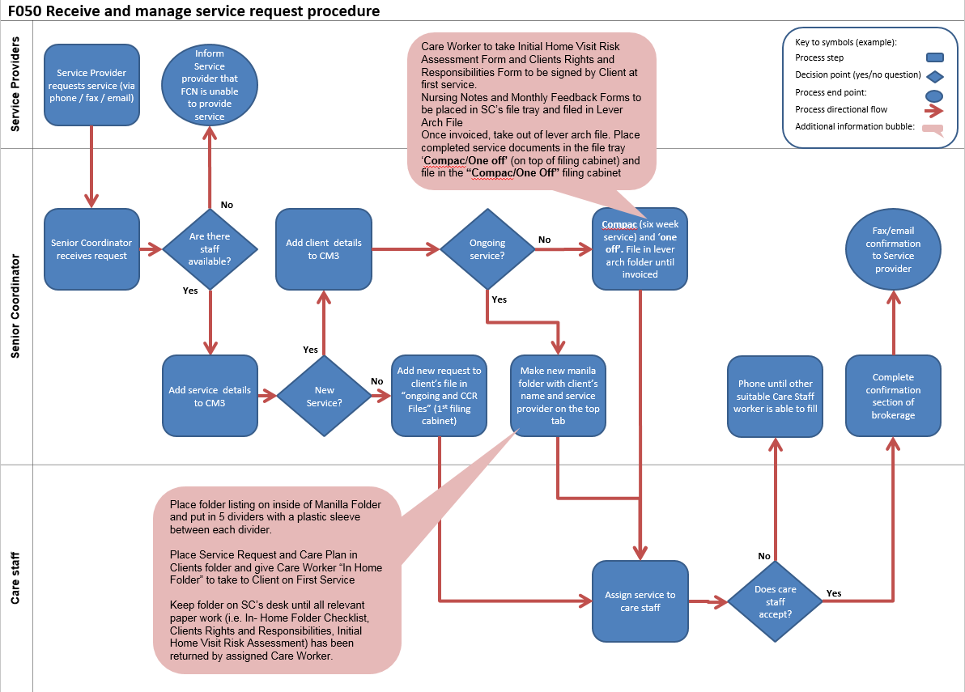

F020 INITIAL HOME VISIT RISK ASSESSMENT
Client name:  Address:  Person completing checklist:  Location of door to enter:  Front Side Back Other  First Call Nursing have been engaged to provide your care service(s) is there/have you any cultural values and beliefs we need to be aware of? | Client provider:  Phone:  Date:  Emergency Details:  Phone #:  Y/N – if yes, please provide details in section provided.  What language is spoken/understood in the household?

Place a if hazard is identified | Unsafe | Place a if hazard is identified | Unsafe
OUTSIDE RESIDENCE |  | BATHROOM / TOILET
Parking and access |  | Access to bath / shower / toilet (use and clean)
Gates (easy to open) Lock working |  | Taps clearly labelled
Pathway / garden |  | Ventilation/
Steps / stairs /railings |  | Handrails
Veranda / porch surface |  | Electrical equipment
Pets (consider allergies, aggression etc) |  | KITCHEN / DINING
Lighting pathway |  | Stove
Doorway clear of obstruction |  | Electrical equipment
INSIDE RESIDENCE |  | Food storage – fridge/cupboards
Floor surfaces |  | Condition – clean/good repair
Lighting – hallways, stairs, living areas |  | LAUNDRY
Signs of pest infestation |  | Taps clearly labelled
Freedom of movement |  | Workspace -access to sink, washing machine, dryer and shelving/cupboards
Squalor
Pets (Consider allergies, aggression etc)
Utensils/appliances storage |  | Clothes line access/adjustable
Weapons e.g. guns |  | Ventilation
Emergency Exit
Ventilation |  | BEDROOMS
Smoke Detector |  | Sufficient space around bed
Personal Care Equipment |  | Bed suitable height
Shower chair |  | Heaters present
Commode |  | Electrical cords / power points
Walking frame
Wheelchair
Hoist/lifter

ELECTRICAL / GAS |  |  | LOUNGE
Portable equipment |  |  | Workspace organisation
Electrical sockets/leads |  |  | Furniture position
Switches / plugs
Gas cylinders
Power points near water
Gas cylinders (hot water heating/oxygen)
Complete this section if domestic assistance is required as part of service
Place a if hazard is identified |  | In disrepair |  | Unavailable | Replacement required
HOUSEHOLD EQUIPMENT
Vacuum cleaner
Carpet sweeper
Broom (eg handle length)
Mop / bucket
Iron / ironing board
Washing machine / dryer
Laundry trolley with basket
Cloths and sponges
Food preparation equipment
Clothes line
Complete the following section if hazardous substances are to be use for cleaning – for example kitchen/laundry/bathroom if identified
Substances not labelled clearly |  | Not stored in safe position
Substances not in original container |  | No exhaust fan / open window
Not suitable for purpose

OTHER ISSUES | if  identified |  | if  identified
History of aggression or violence |  | Risk of infection
Resistance to care |  | Manual handling assessment required
Unable to accept instructions
Please add any risk identified that have not been included in the previous section of this form.

Risk control summary – describe the identified risk/s; rank the risk/s using FC Risk Assessment Table/Matrix and outline a control to address the risk/s in consultation with management and/or service provider
Risk/Hazard identified | Ranking | Strategy to Manage Risk | Implemented
NOTES: Please detail any cultural needs, beliefs and value systems First Call Nursing needs to be aware of?
Is there a current care plan in place? Y/N Dated: …./…./….
Is there a signed service agreement in place? Y/N Dated: …./…./….
Is there a risk assessment in place? Y/N Dated: …./…./….
Inspection conducted by:
Care Worker Name:
Date:
Signature:

Privacy statement:
The purpose of collecting this information is to assist the staff at First Call Nursing in providing the required service/s; no part of this information will be passed onto any other person or organisation without the express permission of the client or their representative.

Declaration:

I, …………………………………………………….., hereby declare that I have given permission for this information to be provided to First Call Nursing

Client or Carer Signature:……………………………………………………………….
F016 - Private In-Home Folder Checklist
Document # |  | when document has been explained
F016 | Private In-Home Folder Checklist
F020 | Initial Home Visit Risk Assessment Checklist
D012 | In Home Front Cover
D011 | First Call Nursing- Information Pamphlet
D009 | Clients Rights and Responsibilities
P092 | Introducing First Call Nursing Pamphlet
D001 | First Call Nursing Rates
F019 | Client Self-Assessment and Service Request
P037 | SWP Client Practices
F010 | Service Record
F011 | Progress/Nursing Notes
P006 | Privacy and Confidentiality
P001 | Complaints and Feedback
F017 | Incident/Complaint (Accident/Near Miss) Form
P005 | Money Handling
F004 | Money Handling Form
P029 | Advocacy
D005 | Advocacy Services -Contact listing
P011 | Abuse
D002 | Aust Gov Charter of Rights & Responsibilities
*Place a tick after policy/procedure/form is explained to client/carer.
Declaration:
I, ……………………………………………………., hereby declare that I have read and understood the information provided to me/carer in this folder relating to ………………………………………………………..
Signed on: of 20
Signed for and on behalf of: ___________________________Carer/Client
Signed for and on behalf of First Call Nursing
Name of Care Worker _______________________
Title: _____________
Signature of Care Worker: _________________________________________

F011 - Progress/Nursing Notes
This page # ………….  Previous # …………. | Taken by ………………………….............
Client Name: | Address:
Care Staff Name: | Phone #:
Phone number: | Sex M/F:

Date  Time | SIGN AND PRINTSURNAME & RECORD DESIGNATION FOR ALL ENTRIES
Refer..G:\FC P & P\Procedures\P032 Nursing Notes Procedures V3.doc

F010 - SERVICE RECORD
Surname:
Given Names:
Address:
Date of birth: Sex:
Care worker:
All care workers are required to sign for each client visit. Duties as per care plan. If there is no change in the client’s condition the care worker is sign beside the corresponding date and time. If there has been a change, tick () in change column and record in progress notes. The service provider is notified.
Date  Time | Signature | Change | Date  Time | Signature | Change
Disclaimer: This tool is only a record and does not replace the care plan.

F021 Risk Assessment Table-Matrix V2.doc
See..F011 Progress_Nursing Notes V3.xls
Refer..G:\FC P & P\Procedures\P034 Service Record Procedure V3.doc

