The complaints management process
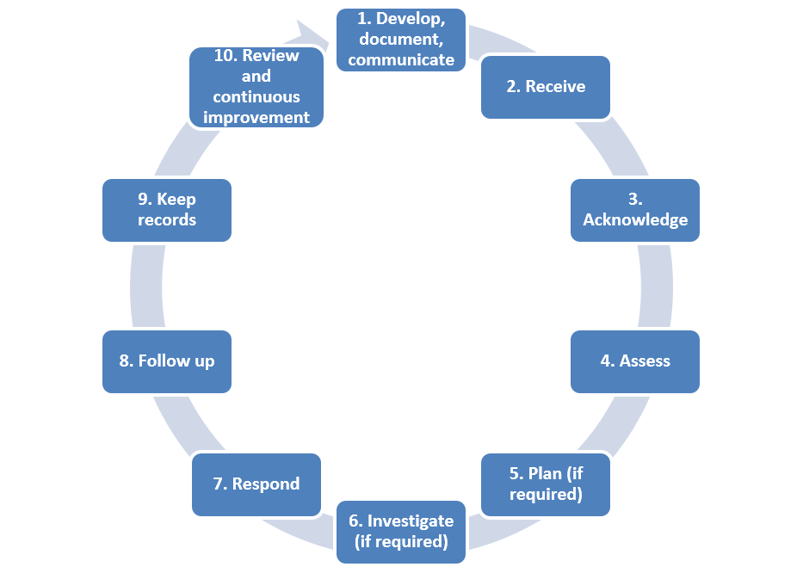

The above diagram sets out the steps involved in the complaints management process, from developing and documenting a policy and procedures, to investigating and reviewing the handling of a complaint.
- Develop, document and communicate the complaints policy and procedures. Make sure stakeholders are involved in the development of the policy, and it is understood by clients, staff and other stakeholders.
- Receive the complaint, listen to the complainant, clarify the issue/s and find out their desired outcome.
- Acknowledge the complaint and inform the complainant of how you will proceed.
- Assess the risk, priority level, and complainant’s desired outcome.
- Plan (if required) what information is needed for the investigation and how it will be obtained.
- Investigate (if required) the complaint, ensuring it is impartial, confidential and transparent.
- Respond to the complaint, explaining how you made the decision, and agree on a response with the complainant.
- Follow up with the complainant, see if they are satisfied with the response, and if not, refer them to the relevant external body for further support or investigation.
- Keep records in a secure and confidential location, for the specified retention period.
- Review data from complaints and analyse how the system could be improved.

